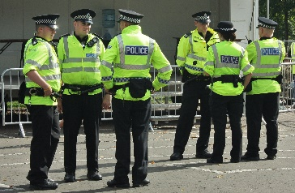

PRE-A LEVEL COURSE
IN SOCIOLOGY

A LEVEL SOCIOLOGY COURSE OUTLINE

The course specification can be accessed here (AQA A level Specification):

https://www.aqa.org.uk/subjects/sociology/as-and-a-level/sociology-7191-7192/specification-at-a-glance

We cover the compulsory units of Education, Theory and Methods, and Crime.
Our optional topics are Families and Households, and Media.

The course is split into three papers with different teachers focussing on the following sections:
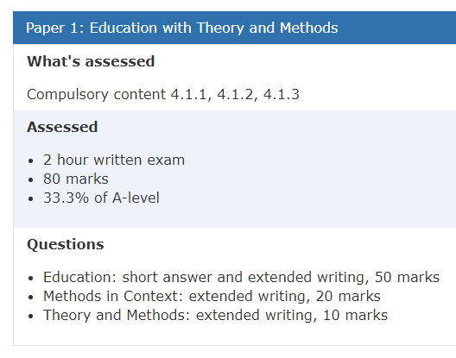

Education and methods taught by Mrs Harris

Families and Households; and Theory taught by Mrs Lee

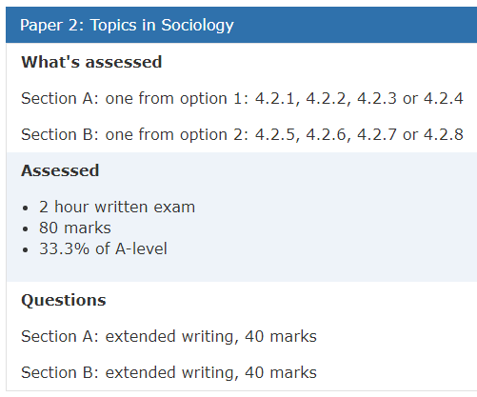

Media is taught by Mrs Harris
Families and Households taught by Mrs Lee
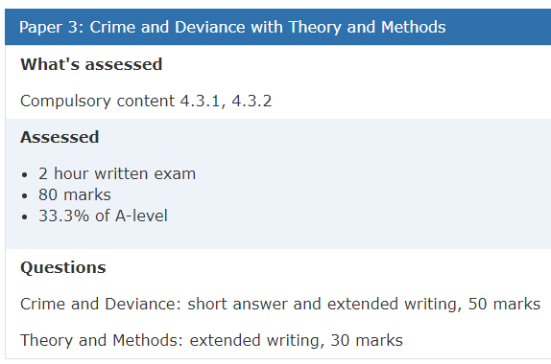
Theory and Methods is taught by Mrs Harris
Crime and Deviance is taught by Mrs Andre

SUMMER TRANSITION WORK

We are so excited to hear that you are hoping to join us in September to study A Level Sociology.
This booklet will give you a brief introduction to the course layout and help you to start getting to grips with some of the key terminology and content so that we can hit the ground running in September.

The first term there are 3 topics we will study. These 3 topics will contribute towards the 3 final exams you will sit in the summer of Year 13.

These three topics are:

- Theories (Where we look at the main sociology theories of Functionalism, Marxism, Feminism & Interactionism)
- Educational Policies (where we start by looking at policies to achieve greater equality of opportunity or outcome)
- Role of the family (where we start looking at applying the theories to Families and Households)

Please complete the tasks below and bring this completed workbook with you in September. We have also added a link onto the picture below (control + click) to information about future career pathways in Sociology, with links for you to do some research!

Best wishes, The Sociology Team

*SUMMER TRANSITION WORK HAND IN WEEK: 11th – 15th SEPTEMBER
INTRODUCTION TO SOCIOLOGY

Click on the link below – it has 3 sections. You have a task to do per section, and you must watch every video.

https://ondemand.tutor2u.net/students/introduction-to-aqa-a-level-sociology-getting-started?fbclid=IwAR1aXid7tpdo7HaQRnwk0sajVHSNAfAs5Kv940Fy-TZVhWKjjSlx6c0DoaA_aem_th_AREB3O5jDsF2clQZjn8wHnbQ4zJFlaYrLMwtCuTEweFZeXN41ZoLzJhqtxxK0BKpzRg

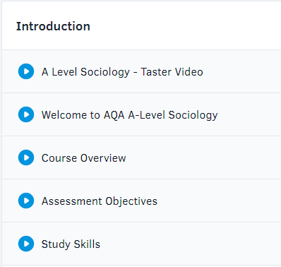
Task one
Watch the videos from the intro section and then write a sentence to explain each of the three assessment objectives.

Scroll down to remaining tasks!

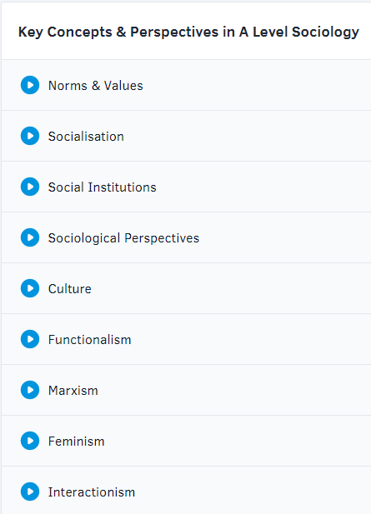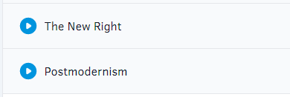
Task Three
Watch the key perspectives in sociology.
Come to class ready to discuss your views on each of them. Make notes on each of them so that you can use them in a discussion.
Task Two
Watch the videos about each of the key concepts listed here.
Complete the table found below on each of the key concepts. We have started the table for you as an example!

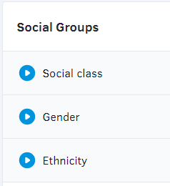
Task Four
Watch the videos about each of the strata in today’s society.
Read the news over the summer and bring in an example of a news article which relates to each of the strata. Bonus points awarded if it relates to a specific sub-strata i.e. Working class boys

Key Concept | What it means | Everyday life example
Norms and Values | Our Values tell us what is good and what we should aim for. They lay down general principles or guidelines. Norms on the other hand are the specific rules that govern behaviour in particular situations. If we fail to keep to a norm then others may “punish” us. | In my house we value the time we spend together as family. We feel it is important that each day we spend some time together talking about our day. It is a norm that we all sit at the table for our meal in the evenings – if I didn’t sit at the table to eat with my family, they would be upset with me.
Socialisation

Social Institutions

Sociological perspectives

Culture

